Left Turn Display Mechanism for Facilitating Left Hand Turns

**Group 19:**

Atef Chaudhury

Jacinta Ferrant

Joey Loi

Michal Ulman

Ali Vira

Elizabeth Yang

***Abstract -*** Drivers making left hand turns are faced with the challenge of making decisions with incomplete information, leading to dangerous situations where an individual may drive into the path of an oncoming vehicle. A modification to current traffic systems was designed to aid drivers by alerting them of oncoming traffic obscured by blind spots. Although some intersections currently use the advance green for left turns, the oncoming traffic must be at a halt. This system will stand out by not having any effect on the oncoming flow of traffic. Unlike competitors’ systems, this system dynamically calculates an unsafe zone based on the speed of oncoming cars, weather conditions, and driver reaction time and intuitively presents this information. The system has the following four functions: detect oncoming traffic, determine the size of left-turning vehicle, calculate an unsafe zone in which a driver cannot safely make a left hand turn, and present the information to a driver in a simple fashion. The first function is achieved through the use of two radars pointed at oncoming traffic, which are able to identify the speed and position of oncoming traffic in up to 10 lanes. Left-turning vehicle classification is achieved through using a camera facing the left-turning vehicle. The third function is achieved through the use of a Raspberry Pi computer with a connection to a weather network. The mean time to make a left turn has been found to be 3.0s at a two-lane intersection. The universal human reaction time used by accident reconstructionists is 1.5 seconds. Both these times were factored into the unsafe-zone calculation. If it is determined that there is not enough time to make a safe left turn, the system signals the left turning driver that it is not safe to go. This function is achieved through the use of a flashing amber light. The system will reset once an oncoming car passes through the intersection. During mechanical testing, the system was able to withstand winds up to 128km/h and temperatures -50ºC to 60ºC. The vehicle detection range was found to be 76.2m, and the power requirement was found to be 23.4Wh. For further improvement, the system will incorporate pedestrian and cyclist detection; use a more accurate algorithm, and features to enhance compatibility.

TABLE OF CONTENTS

Introduction ----------------------------------------------------------------------------------------- 5

Design Criteria ---------------------------------------------------------------------------------------6

Design Refinements ---------------------------------------------------------------------------------9

Design Description -------------------------------------------------------------------------------- 11

Components Overview ----------------------------------------------------------------------------12

Analytical Modelling-------------------------------------------------------------------------------13

Research Summary -------------------------------------------------------------------------------- 14

Algorithm ------------------------------------------------------------------------------------------- 16

Manufacture and Assembly -----------------------------------------------------------------------17

Prototype---------------------------------------------------------------------------------------------18

Failure Modes and Effects ------------------------------------------------------------------------20

Comparison to Target Values -------------------------------------------------------------------- 23

Recommendations --------------------------------------------------------------------------------- 24

Conclusion ----------------------------------------------------------------------------------------- 24

Acknowledgements --------------------------------------------------------------------------------25

References ------------------------------------------------------------------------------------------ 25

Appendix A: Concept Sketches ------------------------------------------------------------------26

Appendix B: Flowchart --------------------------------------------------------------------------- 27

Appendix C: Analytical Modelling --------------------------------------------------------------28

Appendix D: Assembly Instructions ------------------------------------------------------------ 31

Appendix E: Bill of Materials --------------------------------------------------------------------37

TABLE OF FIGURES

Figure 1: Concept 5 Sketch ----------------------------------------------------------------------- 8

Figure 2: Revised Concept 5 --------------------------------------------------------------------- 10

Figure 3: Algorithm Interface --------------------------------------------------------------------18

Figure 4: Not Safe to Turn ----------------------------------------------------------------------- 19

Figure 5: Safe to Turn -----------------------------------------------------------------------------20

Figure 6: Concept 6 Sketch ---------------------------------------------------------------------- 26

Figure 7: Concept 7 Sketch -----------------------------------------------------------------------26

Figure 8: Flowchart of Decision Making Process ---------------------------------------------27

Figure 9: Free Body Diagram of Mounting Pole ----------------------------------------------28

Figure 10: Signal Light Assembly -------------------------------------------------------------- 33

Figure 11: Pole and Cabinet Assembly ---------------------------------------------------------34

Figure 12: Camera Assembly --------------------------------------------------------------------35

Figure 13: Radar Assembly ----------------------------------------------------------------------36

TABLE OF TABLES

Table 1: Algorithm Value Definitions ---------------------------------------------------------- 15

Table 2: Target Value Comparisons -------------------------------------------------------------23

Table 3: Bill of Materials ------------------------------------------------------------------------- 37

INTRODUCTION

Drivers attempting to undertake left turns in motor vehicles often lack enough information to determine when it is safe to do so. With over 172 000 Canadians injured in motor vehicle accidents in 2010[1] alone, the field of road and traffic safety is of paramount importance to the government and to the drivers. In order for drivers to feel secure about their driving safety despite such accident statistics, they place faith in the efficiency of existing traffic systems. However, the current method of peering around stationary cars to gauge the position of oncoming traffic is unsafe as it increases the risk of collision between the left-turning driver and oncoming traffic. This, coupled with varying speeds of oncoming traffic, in-car distractions, blind spots, and weather conditions impacting driver perception time make for a poor environment in which to make a safe calculated decision to turn. A new inexpensive, easy to implement, and intuitive system is needed to help safely facilitate the execution of left hand turns.

There have been previous attempts to implement such a system, however, these systems would not be suitable for common use as they are too expensive to produce, too difficult to implement within existing traffic systems, or too difficult for the average driver to interpret and understand. Furthermore, none of the previous designs adequately address extraneous factors like speeding traffic, driver reaction times, and adverse weather conditions.

Systems which integrate internal vehicle control with external traffic systems such as the Collision in Right/Left Turn Prevention System[2] (CRLTPS) can be used to seize control of a vehicle and alter its course should a collision prove imminent. However, such devices are prohibitively expensive. This is due to the extensive camera array and processing facility that needs to be present at every intersection. They are also impossible to consistently implement. In order for the system to function properly, all cars need to be fitted with new components. Finally, altering the course of a vehicle can compound accidents. Drivers often instinctively attempt to act against the automatic steering.

Other systems such as the Left-Turn Driving Support Device[3] (LTDSD) use reflective materials and optical fibres to help drivers determine the position of oncoming traffic. Despite their apparent simplicity, such systems rely too heavily upon driver intuition to interpret their output. Such systems also run the risk of overloading the driver with too many sources of information. Furthermore, they cease to function under adverse weather conditions. Snow and rain obscure the reflective properties of the materials used by the system.

Some systems, such as the BMW Left Turn Assistant[4] (LTA), attempt to function exclusively within the confines of individual vehicles. They warn drivers about potential incoming collisions by sounding an alarm within the vehicle. However, these systems are usually expensive. They are also only present on specific vehicle brands.

This paper presents a new system – Left Turn Display (LTD) that is easy to integrate with existing traffic systems, within the scope of most municipal traffic budgets, and has been proven as intuitive and easy to understand by the average driver. The system is also functional in adverse weather conditions and is able to consider speeding traffic and driver reaction times in its decision making process. The presented system consists of two radar guns to track the position of traffic. This data is relayed to a central processing unit, where it is combined with existing weather information and driver reaction times, and an unsafe zone for left-turning drivers is calculated. The information is then presented to the driver by a binary safe/not-safe light attached to existing traffic lights. Device design will be outlined in Sections I through IV. Analytical Modelling will be outlined in Section V, followed by a research summary, algorithm, and manufacturing & assembly in Sections VI, VII, and VIII, respectively. The prototype, failure modes, and comparison of target values will be covered in Sections IX, X, and XI, respectively. Recommendations and conclusion will be included in Sections XII, and XIII, respectively.

I. DESIGN CRITERIA

In order to address the functional, structural, cosmetic, and cost limitations of previous attempts to create a system to safely facilitate the execution of a left hand turn, the device was designed based on the following criteria.

* 1. Basic Functions
     1. Determine speed of oncoming vehicle
     2. Detect position of oncoming vehicle
     3. Determine exceptions (slowing down, speeding up, yellow light)
     4. Calculate safe zone for turning vehicle
     5. Determine if oncoming vehicle has crossed safe zone
     6. Relay information to driver in an intuitive manner
  2. Functional Requirements
     1. Increase effective driver visibility range to at least 200m
     2. Relay information to driver within 100ms
  3. Structural Requirements
     1. Combined size of device components should not exceed 1.0m3
     2. Able to withstand temperatures of ±60°C
     3. Able to withstand wind speeds of at least 120km/h
     4. No more than 10 components
  4. Ergonomic Requirements
     1. Visually appealing (must integrate with existing colors)

Design criteria for the maximum device size, cost, and part constraints were determined through the combination of surveys and research. In addition to the above requirements it was essential that the proposed design be easy to integrate in existing systems. Based on the above functions, 7 different concepts were developed. Concept 5 was selected after comparison with the other 6 concepts through a go-no-go analysis and decision matrix.

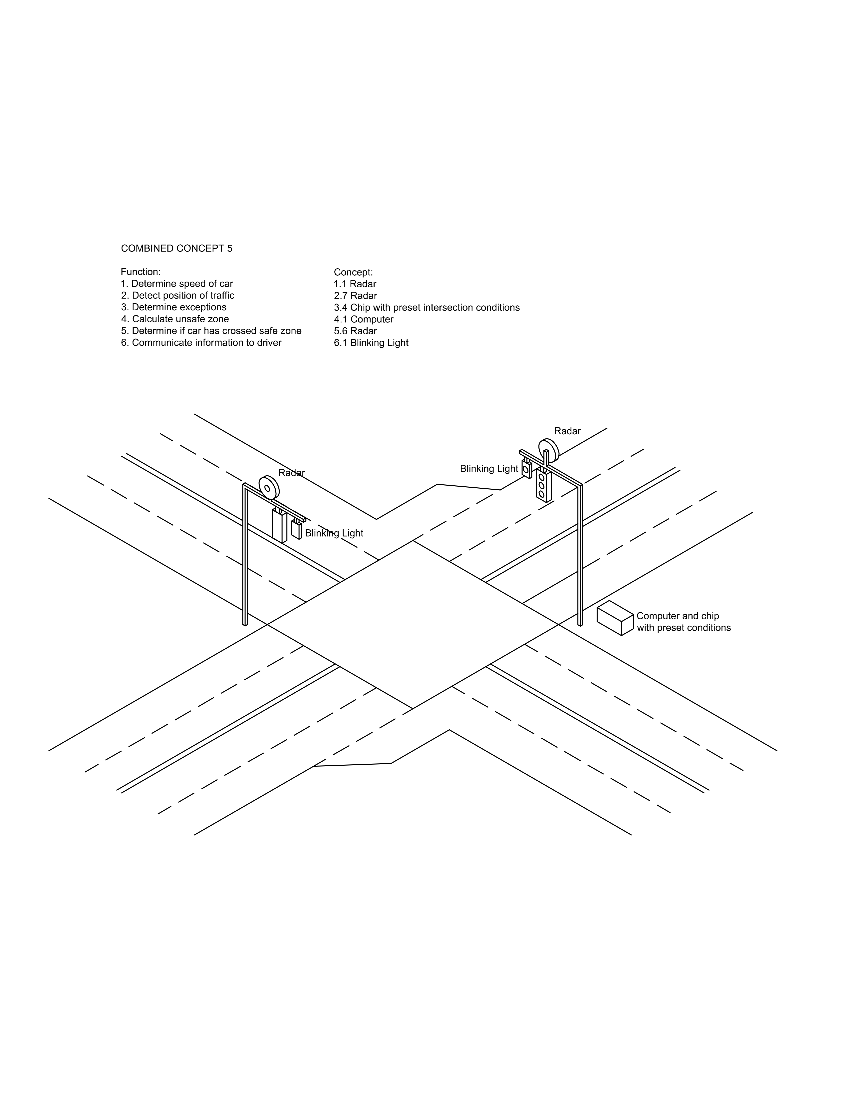

Figure 1: Concept 5 Sketch

Concept 5 (Fig. 1) uses a radar system mounted on opposite streetlights to determine oncoming vehicles’ speeds and positions. The radar collects this information and sends it to a central computer located in a secure box on the pole where it is combined with weather and visibility data obtained from a central network. All this data is processed in order to determine if it is safe for a vehicle to make a left turn. The result is communicated to drivers in the left turn lane through a single blinking light located adjacent to the regular traffic light. If the system determines that it is not safe to turn, the light will flash.

The radar was chosen as the instrument to determine vehicle speed and position over pressure plates and electromagnetic coils (used in concept 6 and 7 respectively) after considering two essential engineering requirements: number of changes to existing intersections and detection range. Pressure plates and electromagnetic coil would require the road be dug up in four places so that they could be installed. This would be a costly and time consuming procedure. Radar does not require major changes in infrastructure. Regarding detection range, radar has a balance between range and accuracy that pressure plates and electromagnetic coils do not. Radar is able to detect if a vehicle changes speed or direction right until it exits the intersection. Pressure plates and electromagnetic coils are static and are not able to detect a vehicle’s changing speed. Other concept features like the central computer and blinking light were consistent across these three concepts. Based on the compatibility and detection range, radar is the most reasonable choice when compared with pressure plates and electromagnetic coils.

II. DESIGN REFINEMENTS

While concept 5 was determined to be the best choice out of 7, further investigation revealed areas for improvement. One factor in left turn safety that was neglected in all earlier concepts was the length of the turning vehicle. In order to accommodate for this, this new function would need to be incorporated into the design. A modified concept 5 now includes a camera that is able to detect the length of turning vehicles and sends this information to the computer. As well, after studying the shapes of light poles, it was recognized that concept 5 needed to be changed in order to be compatible with various types of light poles: curved, straight, and horizontal or vertical in nature. To accommodate for this, the radar, camera, and computer box system is arranged on a vertical pole that attaches to the vertical component of any street light using size-adjustable brackets. All of these modifications to concept 5 resulted in the final design depicted in Figure 2.

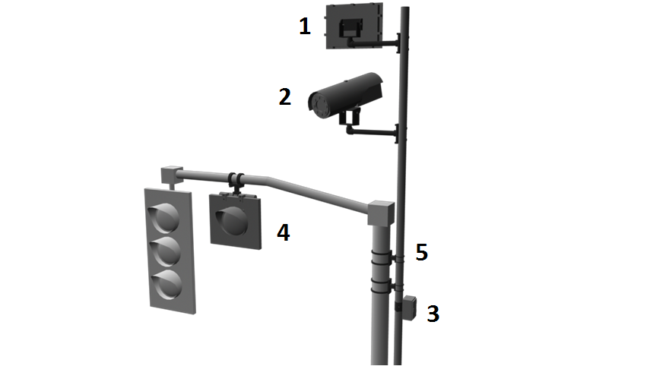

Figure 2: Revised Concept 5

1. Radar facing opposing lanes to detect on-coming traffic
2. Camera facing turning car to capture image of car
3. Central computer used to determine if it is safe to turn

* Use radar data to calculate when opposing traffic will reach the intersection
* Use image processing software along with camera image to determine turning-car length
* Use Wi-Fi chip to gather data on current weather conditions
* Combine pre-set data on intersection size along with weather condition and turning car length to determine time for car to turn
* Determine if there is enough time for the car to turn before opposing traffic reaches the intersection

1. Warning light to inform driver of on-coming traffic
2. Secondary pole and brackets used to attach camera and radar to existing traffic systems. Connecting wires are stored in pole.

Based on the revision to concept 5, the new functions are as follows:

1. Detect the speed of oncoming traffic
2. Determine the size of turning traffic
3. Determine weather conditions
4. Determine visibility conditions
5. Combine collected data with existing data
   1. Approach length
   2. Average driver reaction times
   3. Turn times for vehicle sizes
   4. Turn times under weather/visibility conditions
6. Determine time it takes for vehicle to reach intersection
7. Determine time it takes for vehicle to turn
8. Determine if it is unsafe to turn
9. Communicate information to the driver

III. DESIGN DESCRIPTION

The device consists of five main components: one radar gun, one traffic camera, one central processing computer, and the light. The radar gun is mounted towards the opposing lanes of traffic to track the speed and detect the position of oncoming traffic. The camera is mounted under the radar, facing the turning car, to determine the size of the vehicle attempting to make a left hand turn. The data collected by the radar gun and the camera is then passed to the computer unit. The computer unit combines this data with existing information about the weather and intersection conditions – size, speed limit, number of lanes, traffic cycles. The unit then uses this combined data to determine if the vehicle waiting to turn does not have enough time to safely execute a left turn. If there is not enough time, the light is activated, and continues to blink until there is no immediate danger in making a left-hand turn. When there are no vehicles in the safe zone, the computer deactivates the light. This entire process occurs in real time so that up to date information is always being relayed to the driver. When traffic is turning left from the other side of the intersection, the purpose of the two radar guns is exchanged – thus saving material costs and reducing system complexity.

IV. COMPONENTS OVERVIEW

1. *Radar Gun – Figure 2 [1]*

The LTD takes advantage of the expansive research done on modern traffic radar guns. The radar gun consists of a radio transmitter, receiver, and digital counter. It sends out a radio signal which bounces off the target object. The frequency of returning wave is different than that of the transmitted wave due to the Doppler Effect. From that difference, the radar gun can calculate the speed and position of the object from which the waves bounce[5].

Speed is given by the following equation:

Where ***f*** is the emitted frequency of the radiowaves, ***Δf***is the difference in frequency between the transmitted and received waves, and ***c*** is the speed of light. After the returning waves are received, a signal with a frequency equal to the previously calculated frequency difference is created. This frequency is measured by a digital counter to determine the speed of the vehicle. The second radar gun serves as a ‘trip-sensor’ to determine when a vehicle has exited the intersection. When traffic from the other side needs to turn left, the two radar guns exchange functions

1. *Traffic Cameras – Figure 2 [2]*

The main purpose of the traffic cameras is to determine the size of any left turning vehicles. It also takes into account vehicles that have trailer attachments. Varying vehicle sizes imply varying times required to safely turn. The information acquired by the traffic cameras is relayed to the computer and is combined with all other determined conditions. The activation of the light is regulated accordingly.

1. *Central processing unit (computer) – Figure 2 [3]*

A Raspberry Pi CPU is responsible for combining the radar data with existing data about the intersection, weather, and driver reaction times. It is responsible for processing this information, determining when it is safe for a car to turn, and relaying this information to the driver in the form of a binary safe/not-safe signal. The flowchart in Fig. 8 (See Appendix B) outlines the basic decision making process that the computer will take. The processing speed of the computer is 7500MHz to mitigate any potential delay in communication.

1. *Blinking Lights – Figure 2 [4]*

The primary method of communication with the driver consists of a blinking light. It was determined that a binary signal is simple so as not to overwhelm the driver, yet informative enough so as to allow the driver to make a safe decision. When the computer determines the intersection is unsafe, it relays a signal to the blinking light which will pulse in 1.0s intervals accordingly.

V. ANALYTICAL MODELING

The primary focus of modeling was to ensure that the device would function in all weather conditions and that the device could be fitted to any intersection without negatively impacting the existing system. The summary of results is provided below. For a comprehensive list of calculations, refer to Appendix C.

For the purpose of securing the device in extreme weather conditions a value of 80 mile per hour windspeeds was set as the tolerance target. The following formula was used:

Force = Surface Area * Wind Pressure * Drag Factor

It was determined that at windspeeds of 80 mph, the device would undergo a moment of 68.58 lb. ft. about its attachment point. This moment was caused by the force of the wind on the radar, camera, and attachment pole. Initially the device had only one attaching bracket, which had a maximum threshold of 50 lb. ft. After reviewing the results of the analytical modeling, the design was revised to include two supporting brackets rather than one.

In order to ensure that the device did not negatively impact existing systems, focus was placed on modeling the attachment of the warning light. Given that the supporting pole with radar and camera attachments had minor (less than 0.5ft) horizontal distance from the main vertical structure, it was not considered, as any moments created would be very small.

In terms of the warning light, it was found that the light would have negligible effect on the average traffic structure. With a weight of 4.5 lb. and a horizontal distance of 12.3 ft., the warning light would create a moment of 55.4 lb. ft. about the joints of the main traffic structure. Given that the joints can withstand a moment of approximately 700 lb. ft., the light will not impact the existing traffic structure.

VI. RESEARCH SUMMARY

The algorithm used to determine left turn safety accounts for many variables. Accordingly, research was conducted to determine the magnitude of change that each variable has. The following are a summary of findings:

*A) Average left turn execution time*

American report “Left-Turn Lane Installation Guideline”[6] notes that in the Harmelink model for left turn lanes, the assumption is that it takes a vehicle on average3 seconds to make a left turn at a two lane intersection**,** and 4 seconds at a four lane intersection. As well, the average time it takes a car to exit the advanced left turn lane is 1.9 seconds. This information is based on data collected from field studies in 7 major US cities. This value is being calculated by the algorithm.

*B) Average driver reaction time*

Dr. Marc Green, a specialist in vision and reaction time, through his article “Driver Reaction Time”[7] specifies that the universal reaction time used by accident reconstructionists is 1.5 seconds. On average, it takes 1.5 seconds for the average driver to receive information (light change, decelerating surrounding vehicles, etc.), interpret the information and decide on an action to take, and then take that action. This reaction time varies according by gender, age, the type of signal, and the urgency of the situation.

In the algorithm, 1.5 seconds is added to the time to represent driver reaction time.

*C) Weather and visibility on left turn time*

According to a road safety article published by the European Union[8], in many countries reduced speed limits are enforced during times of poor weather. In France, rain or snow may warrant a decrease in traffic speed of 10 to 20 km/h. For this algorithm, it is assumed that in poor weather, driving speeds are reduced by 15km/h. Also assuming that the average suburban speed limit is 60km/h, a 15km/h decrease in speed means that a car is travelling 25% slower in poor weather. Deriving from this article, it can be deducted that a car will need 1.25 times the amount of time to make a left turn during poor weather than pleasant weather.

In this algorithm, the weather can increase the time it takes to execute a left turn by a magnitude of between 1.0 and 2.0. The total time will be multiplied by (1 + k0.1) where k is less than or equal to 10 and where k increases as risk when taking left turn increases. If the weather is pleasant and will not increase risk during left turns, k will equal 0 and the total time will be multiplied by the 1.0. If the weather makes it incredibly dangerous to execute a left turn (sleet, hail, etc.), k will equal 10 and the total time will be multiplied by 2.0.

VII. ALGORITHM

Information gathered from the radar, camera, and network are interpreted by an algorithm to determine how much time it would take a vehicle to turn, the time left until the nearest vehicle will enter the intersection, and ultimately whether or not it is safe for a driver to execute a left turn.

The algorithm to determine how much time it takes for a vehicle to turn left considers 5 variables: turning time, size of the vehicle, visibility conditions, and weather conditions. The product is increased by the average driver reaction time.

turningTime = (size[userSize] * visibility[userVisibility] * weather[userWeather] ) + userReaction;

Table 1: Algorithm Variable Definitions

|  |  |  |  |
| --- | --- | --- | --- |
| **Variable** | **Possible values** | **Explanation** | **Input origin** |
| *size* | 0.75, 1.0, 1.25 | Size of turning vehicle | Camera |
| *visibility* | 1.0, 1.1, 1.2, 1.3, 1.4, 1.5 | Nature of road- curved, hilled, visual distraction | Network |
| *weather* | 1.0, 1.1, 1.2, 1.3, 1.4, 1.5, 1.6, 1.7, 1.8, 1.9, 2.0 | Weather conditions that affect driving performance | Network |
| *userReaction* | 1.5 | Average driver reaction time | Preset |

The algorithm to determine the amount of time before a vehicle enters an intersection considers the speed of the vehicle and the distance it is from the intersection.

oncomingTime = (approachDistance[userApproach]/speed[userSpeed]);

Both these variables are retrieved from the radar.

The values of turningTime and oncomingTime are compared to each other to determine whether or not it is safe for a vehicle to execute a left turn. If turningTime is greater than or equal to oncomingTime, it is unsafe for a vehicle to turn and the light will blink to indicate danger. If the turningTime is less than the oncomingTime, it is safe for a driver to turn and the light will be off.

VIII. MANUFACTURE AND ASSEMBLY

*i) Design for Manufacture*

Given that the product is composed entirely of standard/existing parts, manufacturing considerations had a limited role in the design process. The traffic attachments are composed solely of the standard parts used for general traffic systems. The camera, radar and computer system are all pre-existing devices that were not modified for our design. Therefore no manufacturing processes were required for those devices.

*ii) Design for Assembly*

Individual DFA sheets were evaluated. The score average of these DFA worksheets came out to be approximately 67%, with 69 out of a maximum possible score of 104. The score came out lowest in the category of Part Handling due to asymmetric parts. However, the design scored well in terms of reduction of fasteners and accessibility of parts. Fasteners were reduced by using apparatuses that attach to poles via the tightening of bands and screws. Most of the device components were easy to find and replace as most of them utilized off-the- shelf standard parts. The use of a common base that did not need to be adjusted led to high scores in the *Overall Assembly* category. This is because the main vertical pole onto which the support tube that carries the radar, camera, and cabinet already exists in most common intersections. The same would apply to the horizontal pole holding the alerting light and the regular traffic lights. Both poles do not need to be repositioned. Apart from a lack of chamfers and self-guiding parts, the design scored well.

IX. PROTOTYPE

To model the algorithm, a prototype program was created using C++. As seen in the figure below, it accepts the following variables: Approach distance, oncoming speed, turning vehicle size, weather, visibility and outputs the following values: Turning time, Oncoming time  
  
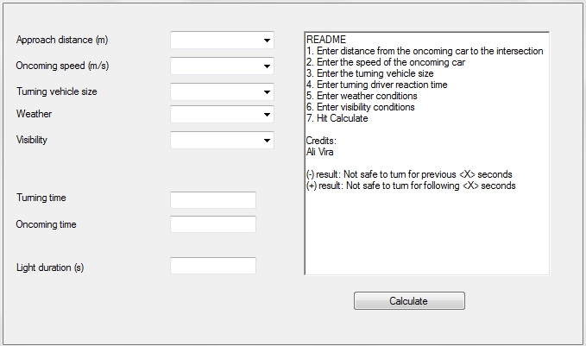  
  
A sample case for a large vehicle trying to make a left turn on a curved road while it is rainy with a fast vehicle approaching the intersection will be processed as follows: 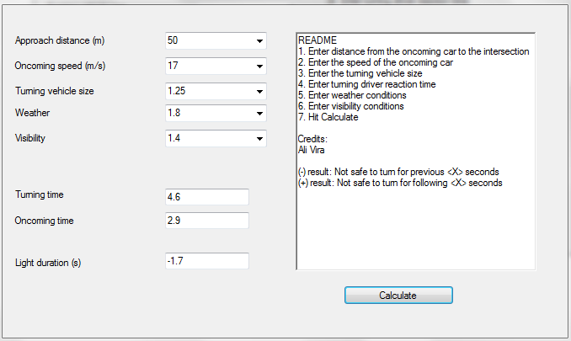  
  
The algorithm has determined that it will take the large vehicle 4.6 seconds to turn, while it will take the oncoming vehicle 2.9 seconds to arrive at the intersection. Since it will take longer for the vehicle to turn than for the vehicle to arrive at the intersection, it is not safe to turn and this will be communicated to the driver as a flashing light.   
  
Another sample case may be for an average sized vehicle making a left turn on a straight road on sunny day with an oncoming vehicle arriving slowly to the intersection from a great distance away:  
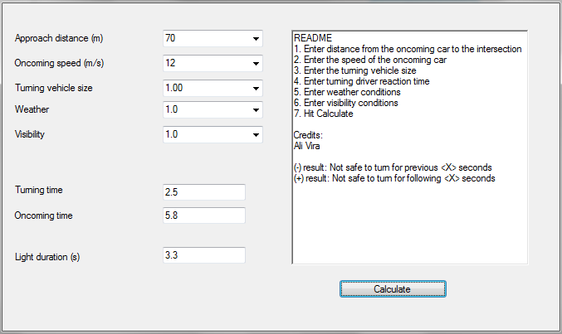  
  
The algorithm has determined that the vehicle can execute the turn in 2.5 seconds while the oncoming vehicle will arrive at the intersection in 5.8 seconds. Therefore, it is safe for the vehicle to turn, and this will be communicated with an off light.

Figure 3: Algorithm Interface

Figure 4: Not Safe to Turn

Figure 5: Safe to Turn

X. FAILURES MODES AND EFFECTS

Given the severe consequences of traffic system failure, an analysis was performed on the failure modes of each of the design functions. Below follows the summary of the consequences of failure for each of the five primary functions:

1. The first function was to detect the speed and position of oncoming traffic through a radar system. Should the system fail to detect oncoming traffic or detect oncoming traffic incorrectly, the consequence of this would be that the warning light would fail to flash or flash at incorrect times. The causes for this could range from manufacturing defects of the radar, incorrect radar positioning/assembly, or damage incurred while the radar was in use.

To address any issues that may stem from the manufacturer. The supplier has been required to submit failure test results. In order to ensure proper assembly, a detailed set of assembly instructions (Appendix D) were created. It has been recommended that a professional engineer be present during assembly and installation.

To address any damage that occurs during use, a wifi chip was installed onto the central processing computer. This chip will ultimately alert a technician should an error be noticed during device operation.

1. The second function was to determine the size of the turning vehicle. For this purpose a traffic camera was equipped with image recognition software. Failure modes concerning the camera specifically are identical to those considered for the radar (poor manufacturing, improper installation, or damage incurred during use). The solution to these problems is also identical to the solutions outlined under the radar failure protocol.

Considering the image detection software, a failure mode would be that the program has failed to correctly determine the size of turning cars. This would result in the warning light flashing for incorrect durations. To address this, rigorous testing has been planned on the software to be used, specifically, it is required that the software have 99.99% accuracy for 10 000 trials.

1. The third function was that the device gathers data on the current weather and visibility conditions using a wifi chip embedded in the central computer. If the chip fails to deliver, or delivers incorrect weather data, the warning light will display for incorrect amounts of time. Issues such as this will likely stem from faulty manufacturing. The supplier will therefore need to submit failure tests for the chip.
2. The fourth function was that the weather, visibility, oncoming traffic, and turning traffic size data be combined with existing data on driver reaction and turning times to calculate whether it is unsafe to turn. If the computer required to perform this calculation does not function properly, it is likely due to either faulty manufacturing or poor algorithm design.

For the former, procedures similar to the ones used for radar, camera, and weather failure protocols will be used in that the manufacturer will be required to submit the results of failure tests. For the latter, rigorous testing on the accuracy of the algorithm must be performed before the device enters mainstream circulation. Specifically, the target would be to reach an accuracy of 99.99% over the course of 10 000 trials.

1. The final function was that the driver be informed about oncoming traffic through the means of a warning light. The light could malfunction for all of the reasons listed throughout the previous failure analyses, as well as faulty manufacturing. The failure resulting from failures in previous functions have been addressed in their respective failure protocols. Improper manufacturing would once again be addressed by the supplier submitting failure tests for the light.

From the individual analyses of the failure modes of each of the respective functions it has been found that the primary consequence is that the warning light fails to flash or flashes at the incorrect times. The question now becomes what is the consequence of this on the overall system. In the design considerations for the system it was specifically indicated that the light would never indicate safety – only danger, or would be turned off. This binary method of display puts the burden of responsibility on the driver as opposed to the system. The system serves as an aid, left turn safety considerations and the ultimate decision to make a left turn is on the driver. Legal research indicated that there is precedence for this. In instances where a normal traffic light malfunctions (i.e. both directions of traffic have a green light), responsibility for accidents has still been placed on the driver as ultimately they must use adequate caution when approaching an intersection regardless of what the traffic light displays.

Relating this to the event of a malfunction, the warning light will fail to flash at times when it unsafe to turn. The warning light will never incorrectly indicate safety, and thus the driver will never actually be misinformed about oncoming traffic. It is assumed that there will be negligible risk to of accident when the light fails to function properly. Given that there is a wi-fi chip installed in the central computer used to inform central authorities of malfunction, the device will remain in a state of improper function for length periods of time.

The fact that there is negligible risk of an accident is still ultimately an assumption. It is possible that drivers will interpret no light as a measure of safety, rather than an unknown state of caution that it is intended to represent. For this, user testing will be required in order to determine how drivers actually interpret the system.

XI. COMPARISON TO TARGET VALUES

Table 2: Target Value Comparisons

|  |  |  |  |  |
| --- | --- | --- | --- | --- |
| **Parameter** |  | **Target Values** | | **Actual Values** |
|  | **Units** | **Disgusted** | **Delighted** |  |
| Changes to The Existing Traffic System | # | 5 | 2 | 4 |
| Processing Speed | MHz | 5000 | 7500 | 700 |
| Detection Range | m | 150 | 250 | 76.2 |
| Temperature Range | °C | -50 to 50 | -50 to 51 | -50 to 60 |
| Cost of Materials | $CDN | 5000 | 2000 | 3670.36 |
| Visibility Range | m | 150 | 250 | 76.2 |
| Power Requirement | Wh | 400 | 100 | 23.4 |
| Number of Parts | # | 15 | 10 | 17 |
| Display Time | ms | 100 | 20 | 2 |
| Cost of Assembly | $CDN | 1500 | 1200 | 2000 |
| Time to Install | hr | 48 | 24 | 24 |

A less than expected number of final parameters fell within the range of the original goals. However, this is likely because the target parameters were far too ambitious. The main parameters with need for improvement are the visibility and detection ranges of the device. Though the final parameters did not meet the desired target, they are ultimately realistic and still provide an accurate evaluation of oncoming traffic. The design can still proceed, but stands to improve with further advancements in technology.

XII. RECOMMENDATIONS

There are several improvements that can be made to the system. The design could be modified to account for pedestrian and cyclist traffic by installing more cameras at intersections. The quality of the current camera image processing could be developed further by using higher precision cameras in order to improve the accuracy of real time detection parameters. The current raspberry pi processor could stand to be faster, allowing again for increased accuracy and decreased calculation time. In the future more powerful radar guns should be considered in order to increase detection range. Although the current algorithm attempts to deal with unexpected events such as weather conditions and vehicle size, it could be modified to allow for a more effective handling of these events should other unexpected variables arise. Some of these variables could include slippery roads after an icy, rainy, or snowy night, or being able to detect car sizes during nighttime. At the current stage, most of these improvements cannot be implemented due to a trade off with the specified cost target, or because the current technology is not yet viable.

XIII. CONCLUSION

A new system that helps safely and intuitively facilitate the execution of left hand turns in a motor vehicle was designed. The system is more affordable, more easily integrated, and more user-friendly than existing systems. Reiterations will include a more accurate algorithm, design changes to increase compatibility, and features to account for pedestrian safety.

ACKNOWLEDGEMENT

The authors would like to thank Dr. J Kofman and the SYDE 161 TAs for the continued guidance and instruction throughout the entire design process.

REFERENCES

[1] Canadian Motor Vehicle Traffic Collision Statistics: 2010 - Transport Canada . (n.d.). Transport Canada / Transports Canada. Retrieved November 12, 2012, from http://www.tc.gc.ca/eng/roadsafety/tp-1317.htm

[2] Patent US6459991 - Collision in right/left turn prevention system - Google Patents. (n.d.). Google. Retrieved November 12, 2012, from http://www.google.com/patents/US6459991

[3] Patent US6827522 - Left-turn driving support device - Google Patents. (n.d.). Google. Retrieved November 12, 2012, from http://www.google.com/patents/US6827522

[4] BMW Left Turn Assistant. (n.d.). MotorAuthority. Retrieved November 12, 2012, from http://www.motorauthority.com/news/1060126_bmw-left-turn-assistant-increasing-safety-at-intersections

[5] How Radar Guns Work. (n.d.). Radar Guns. Retrieved November 12, 2012, from http://www.radarguns.com/how-radar-guns-work.html

[6] Wolff, T., Fitzpatrick K. (July 2003). Left-Turn Installation Guideline. Retreived from http://www.urbanstreet.info/2nd_sym_proceedings/Volume%202/Fitzpatrick.pdf

[7] Green, M. (2009). Driver Reaction Time. Retreived from http://www.visualexpert.com/Resources/reactiontime.html

[8] [3] Current Speed Limit Policies. Retreived from http://ec.europa.eu/transport/road_safety/specialist/knowledge/speed/speed_limits/current_speed_limit_policies.htm

APPENDIX A: CONCEPT SKETCHES

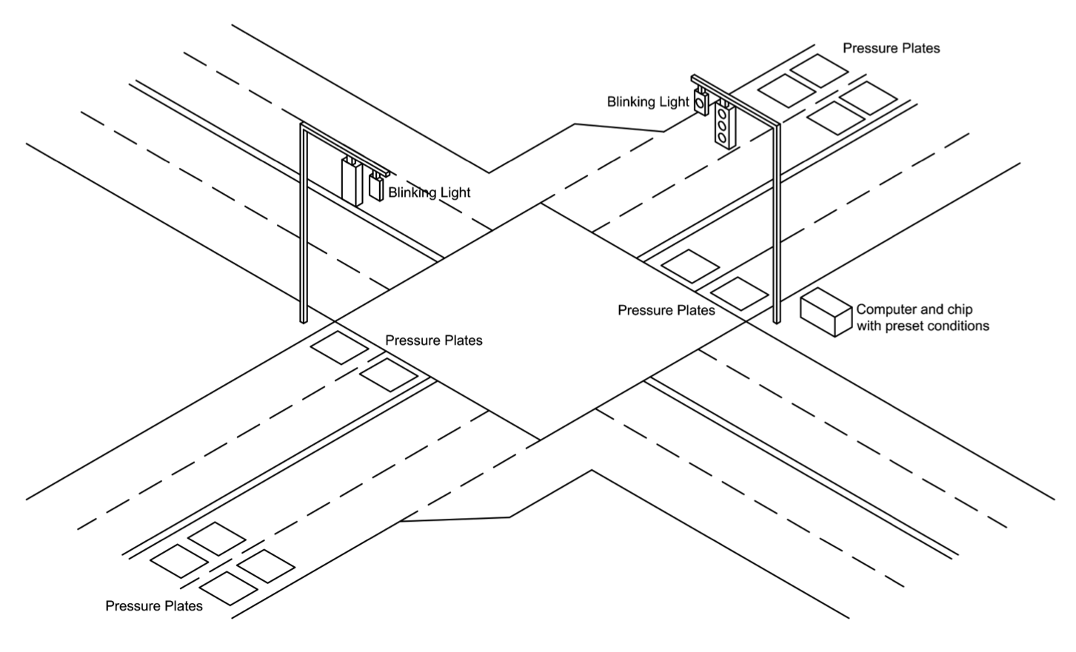

Figure 6: Concept 6 Sketch

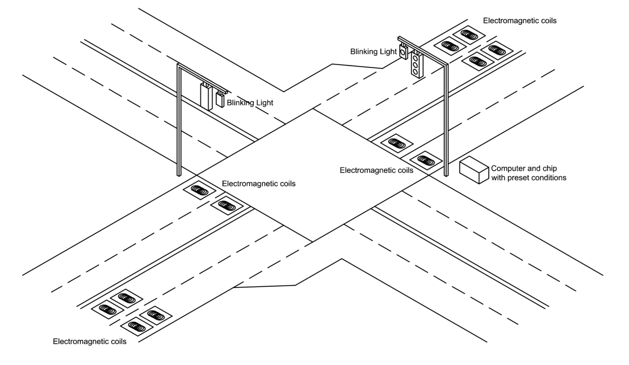

Figure 7: Concept 7 Sketch

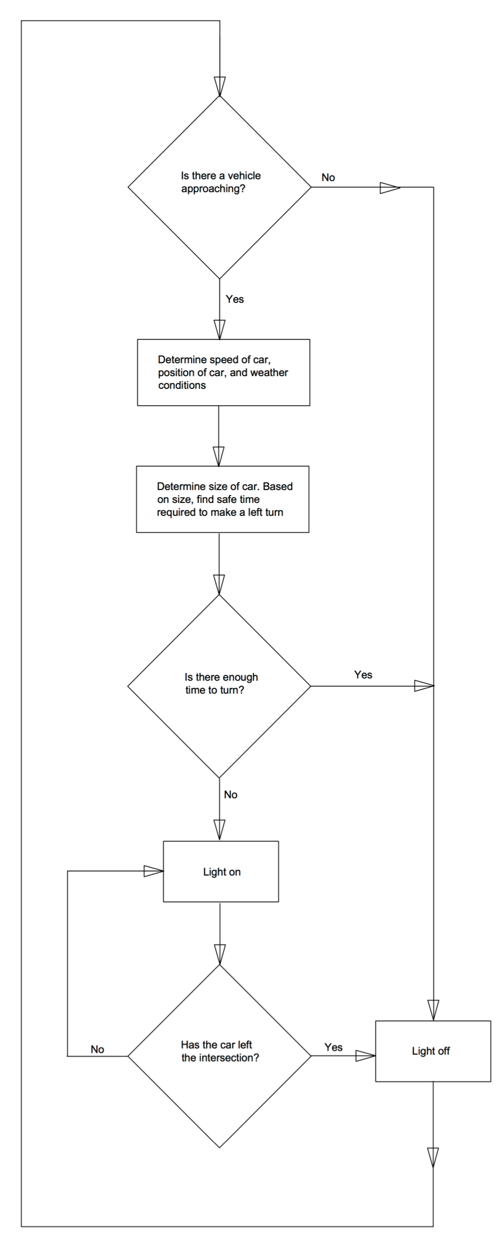APPENDIX B:

FLOWCHART

Figure 8: Flowchart of Decision Making Process

APPENDIX C: ANALYTICAL MODELLING

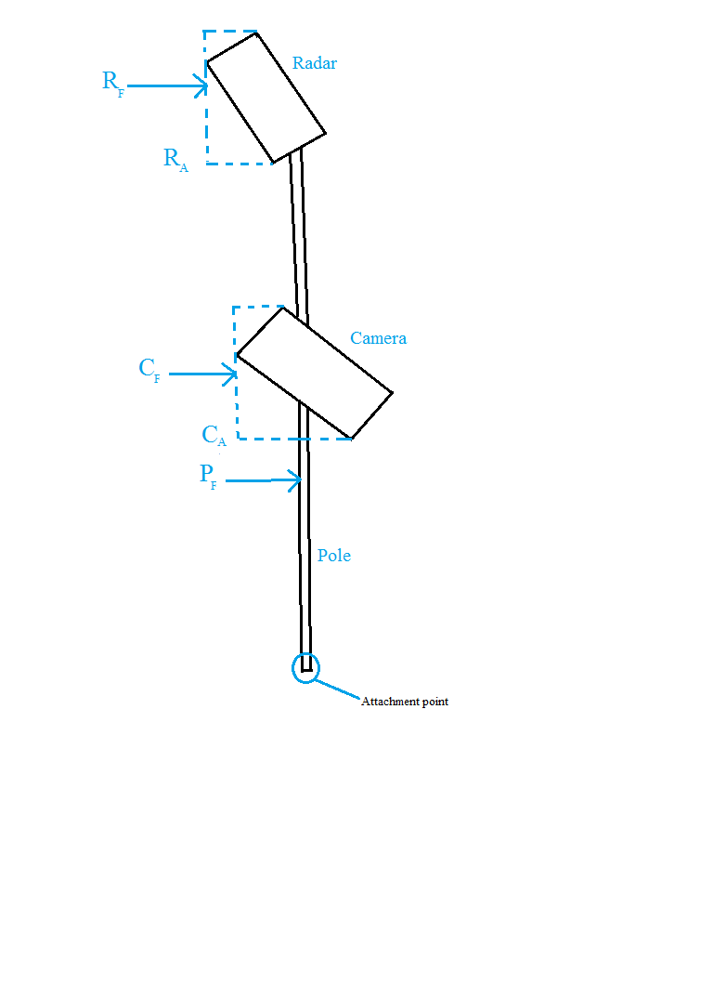**Weather Resistance Calculations**

**Given Data:**

Radar Weight : 15.2 lbm

Camera Weight : 7.8 lbm

Horizontal distance of camera and radar from pole: (.42 feet in opposite directions)

Radar Dimensions: Rl x Rh x Rw

(1.1ft x .28 ft x .88ft)

Camera Dimensions: Cl x Ch x Cw

(.83ft x .33ft x .33ft)

Pole Length x Diameter: Pl x Pd

(2.5ft x .13ft)

Tilt of Camera and Radar: Ct , Rt

(both 20 degrees)

Max wind speed: Wmax (81 mph)

Threshold Moment of one bracket:

50 lb ft

Wind direction: From the rear

Figure 9: Free Body Diagram of Mounting Pole

**Calculations (Moment from mass):**

Moment from Radar = 15.2 lb * .42 ft = 6.38 lb ft

Moment from Camera = 7.8 lb * .42 ft = 3.28 lb ft

Net Moment = 6.38 lb ft – 3.28 lb ft (As devices are places on opposite ends of the pole)

= 3.10 lb ft

**Calculations (Moment from wind):**

Surface Area Radar (RA) = Rw * Rh * cos (Rt) + RW * Rl * sin (Rt)

= (.88 ft) *(.26 ft) + (.88 ft) *(.38 ft)

= .56 ft2

Surface Area Camera (CA) = Cw * Ch * cos (Ct) + Cw * Cl * sin (Ct)

= (.33 ft) *(.31 ft) + (.33 ft) *(.28 ft)

= .19 ft2

Force on Radar (RF) = RA * Wind Pressure * Drag Coefficient

= (.56 ft2) * (.00256 * 812 [Wmax]) * 2.0 (for flat surface)

= 18.8 lb

Force on Camera (CF) = CA x Wind Pressure x Drag Coefficient

= (.19 ft2) * (.00256 * 812 [Wmax]) * 2.0 (for flat surface)

= 6.38 lb

Vertical Distance from end to center of radar: Rd = 2.2 ft

Vertical Distance from end to center of camera: Cd = 2.5 ft

Moment caused by the wind on the Radar (RM) = RF * Rd

= 18.8 lb * 2.2 ft = 41.4 lb ft

Moment caused by the wind on the Camera (CM) = CF * Cd

= 6.38 lb * 2.5 ft = 16.0 lb ft

Surface Area Pole (PA) = Pl * Pd = 2.5 ft * .13 ft = .32ft2

Force on Pole (PF) = PA * Wind Pressure * Drag Coefficient

= (.32 ft2) *(.00256 * 812 [Wmax]) * 1.2 (for rounded surface)

= 6.45 lb

Vertical Distance from end to center of pole:

d = (2.5ft / 2) = 1.25 ft

Moment cause by wind on pole (PM) = PF * d

= 6.45 lb * 1.25 ft = 8.06 lb ft

**Total Moment:**

M = Net moment of mass + RM +CM + PM

= 3.10 lb ft + 41.4 lb ft + 16.0 lb ft + 8.06 lb ft

= 68.56 lb ft > 50 lb ft (Threshold Moment)

**Conclusion:**

The device will need a second bracket to resist the maximum wind speed

**Impact on Existing Systems Calculation**

**Given Data:**

Weight of warning light: 4.5 lb

Horizontal distance of light from the vertical component traffic support: 12.3 ft.

Maximum moment allowed about attachment to vertical component: 700 lb. ft.

Moment created by warning light: 4.5 lb * 12.3 ft = 55.4 lb ft < 700 lb. ft.

**Conclusion:**

The moment caused by the addition of the warning light is much less than the threshold moment. Thus the effect of attaching a warning light to existing traffic systems is negligible.

APPENDIX D: ASSEMBLY INSTRUCTIONS

*NOTE: BE AWARE OF POSSIBLE RIPPED OR TORN WIRES AND DAMAGED EQUIPMENT AND ENSURE PARTS DO NOT TANGLE OR INTERFERE WITH PRE-CONSTRUCTION WIRES OR OTHER PARTS EXISTING ON THE SITE.*

**Section 1: Instructions to Attach Alerting Light to Main Traffic Lights**

1. Slide the 6 inch length of the *Support tube, 2” NPS* inside the side with the smaller ring of the *Astro-Brac Clamp Kit, Horizontal Articulated Band Mount* and fasten.
2. Fasten *Poly Signal Module -8in. Yellow Lens* with wrench in two places on the hinges at top of metal cover of light, using 4 provided hexagonal bolts.
3. Place apparatus about 10 inches to the right of the first left-most traffic light on horizontal pole. Loosen metal bands of band mount, and wrap around main horizontal traffic pole, then fasten with wrench.

**Section 2: Instructions to Attach Secondary Pole to Main Vertical** **Traffic Light Pole**

1. Snap *Support Tube, 2” NPS, Alum* to one of the two *Astro-Brac Clamp Kit, Horizontal Articulated Cable Mount w/ Tube Saddle* with Stainless Steel Fasteners
   1. First cable mount snapped on support tube 20 inches from the bottom.
   2. Second cable mount snapped on 10 inches above the first cable mount.
2. Other side of cable mounts should be loosened, wrapped, and fasted with a wrench 15 inches from the top of the main vertical light pole.

**Section 3: Instructions to Attach Camera to Secondary Pole**

1. Place *"Camera Bracket, 2-Piece, Extended Tilt & Pan Vertical Mount, Alum"* 15 inches from top of support tube so that it is facing towards left-turning traffic across the intersection.
2. Fasten in place with wrench.
3. Fasten *36PCS IR LED 420TVL cctv traffic camera* to camera bracket with wrench.

**Section 4: Instructions to Attach Radar Sensor to Secondary Pole**

1. Place second camera bracket5 inches from the top and facing oncoming traffic.
2. Fasten in place with wrench.
3. Fasten *SmartSensor HD Model 125* to camera bracket with wrench.

**Section 5: Instructions to Attach Onsite Computer to Main Vertical Traffic Light Pole**

1. Refer to diagram of *Mounting Kit, 3” (3-1/2” OD) Post* and use all parts and fasteners included in kit to fasten in the correct order to back of *Flasher Cabinet Assy with Police Type Lock* with screwdriver.
2. Loosen back metal apparatus of kit to attach cabinet to secondary vertical pole previously attached.
3. Place cabinet 15cm from the bottom of the pole, and fasten metal apparatus back so that cabinet firmly attached to pole.
4. Before inserting computer into cabinet, encase computer in plexi-glass and encase wires extending from computer in rubber tube
5. Insert computer inside cabinet and train wires from computer out through back of cabinet up secondary pole.
6. Continue to train wires up, and attach the black and red wires to the camera, and the blue and pink wires to the radar sensor.
7. Wrap and fasten band strap with wrench half way between cabinet and radar around the support tube and main vertical pole. Connect the wires to their color-coded corresponding sockets.
8. Train last set of purple wires along pole, towards alerting light. Connect the wires to their color-coded corresponding sockets.

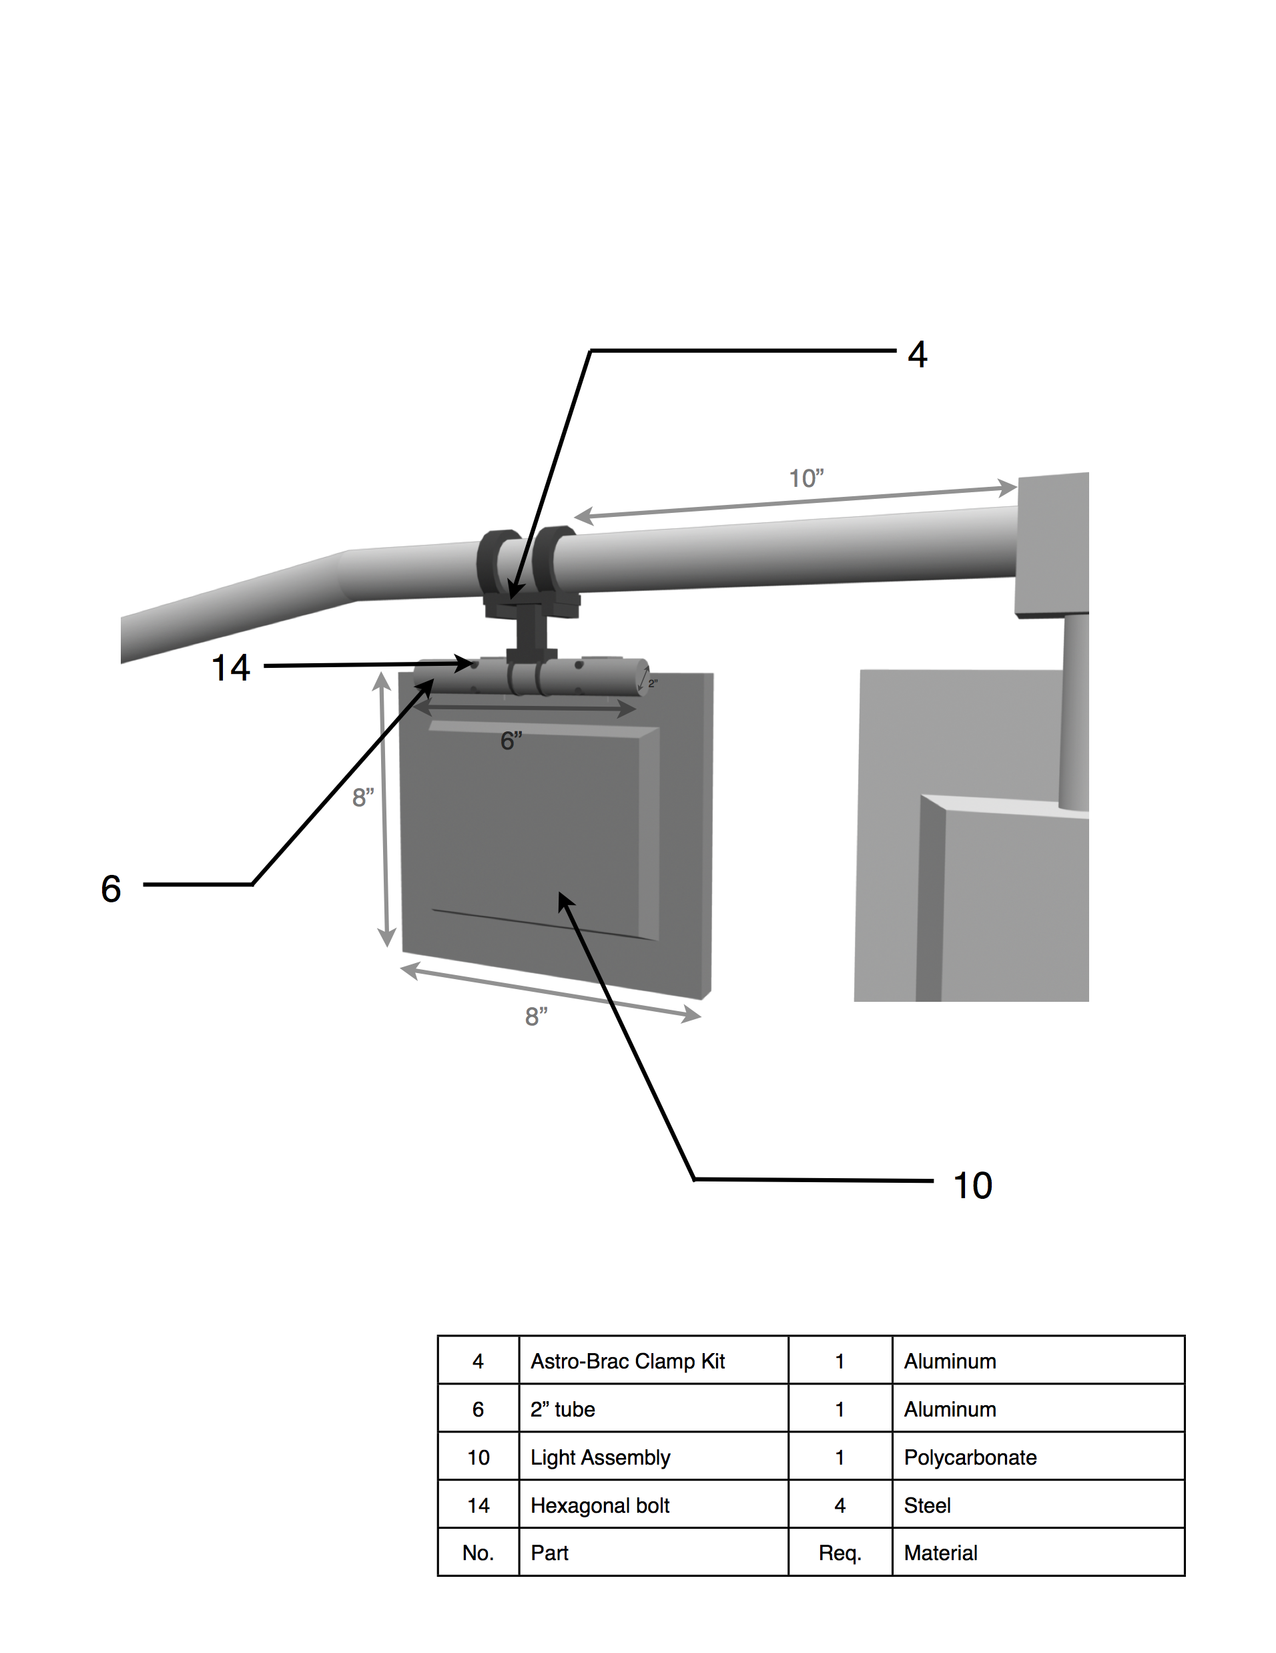

Figure 10: Signal Light Assembly

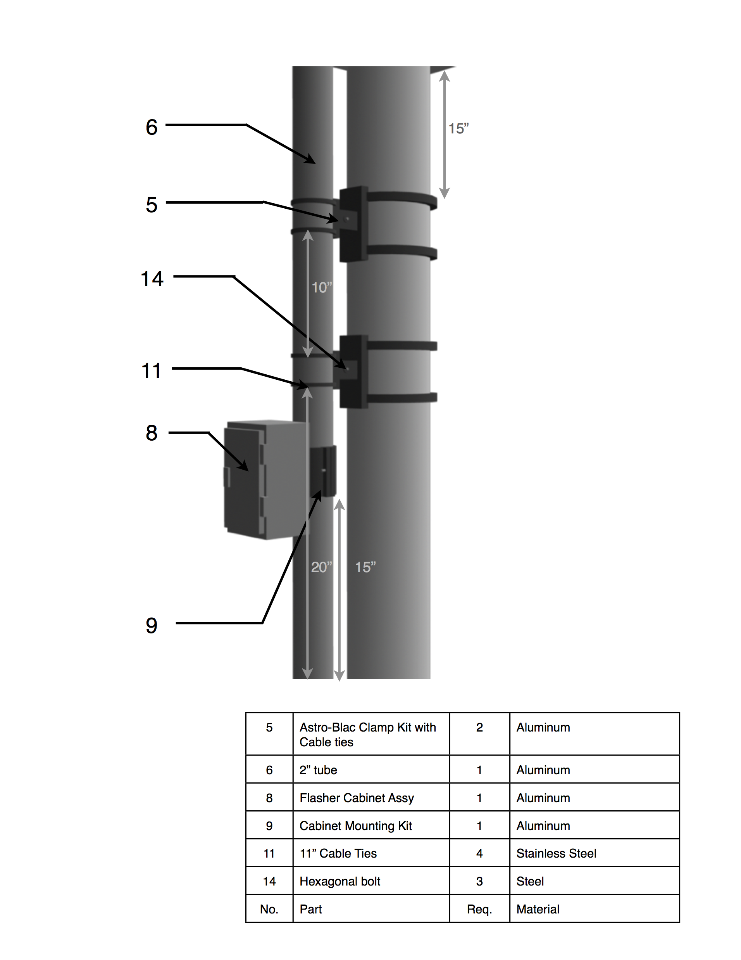

Figure 11: Pole and Cabinet Assembly

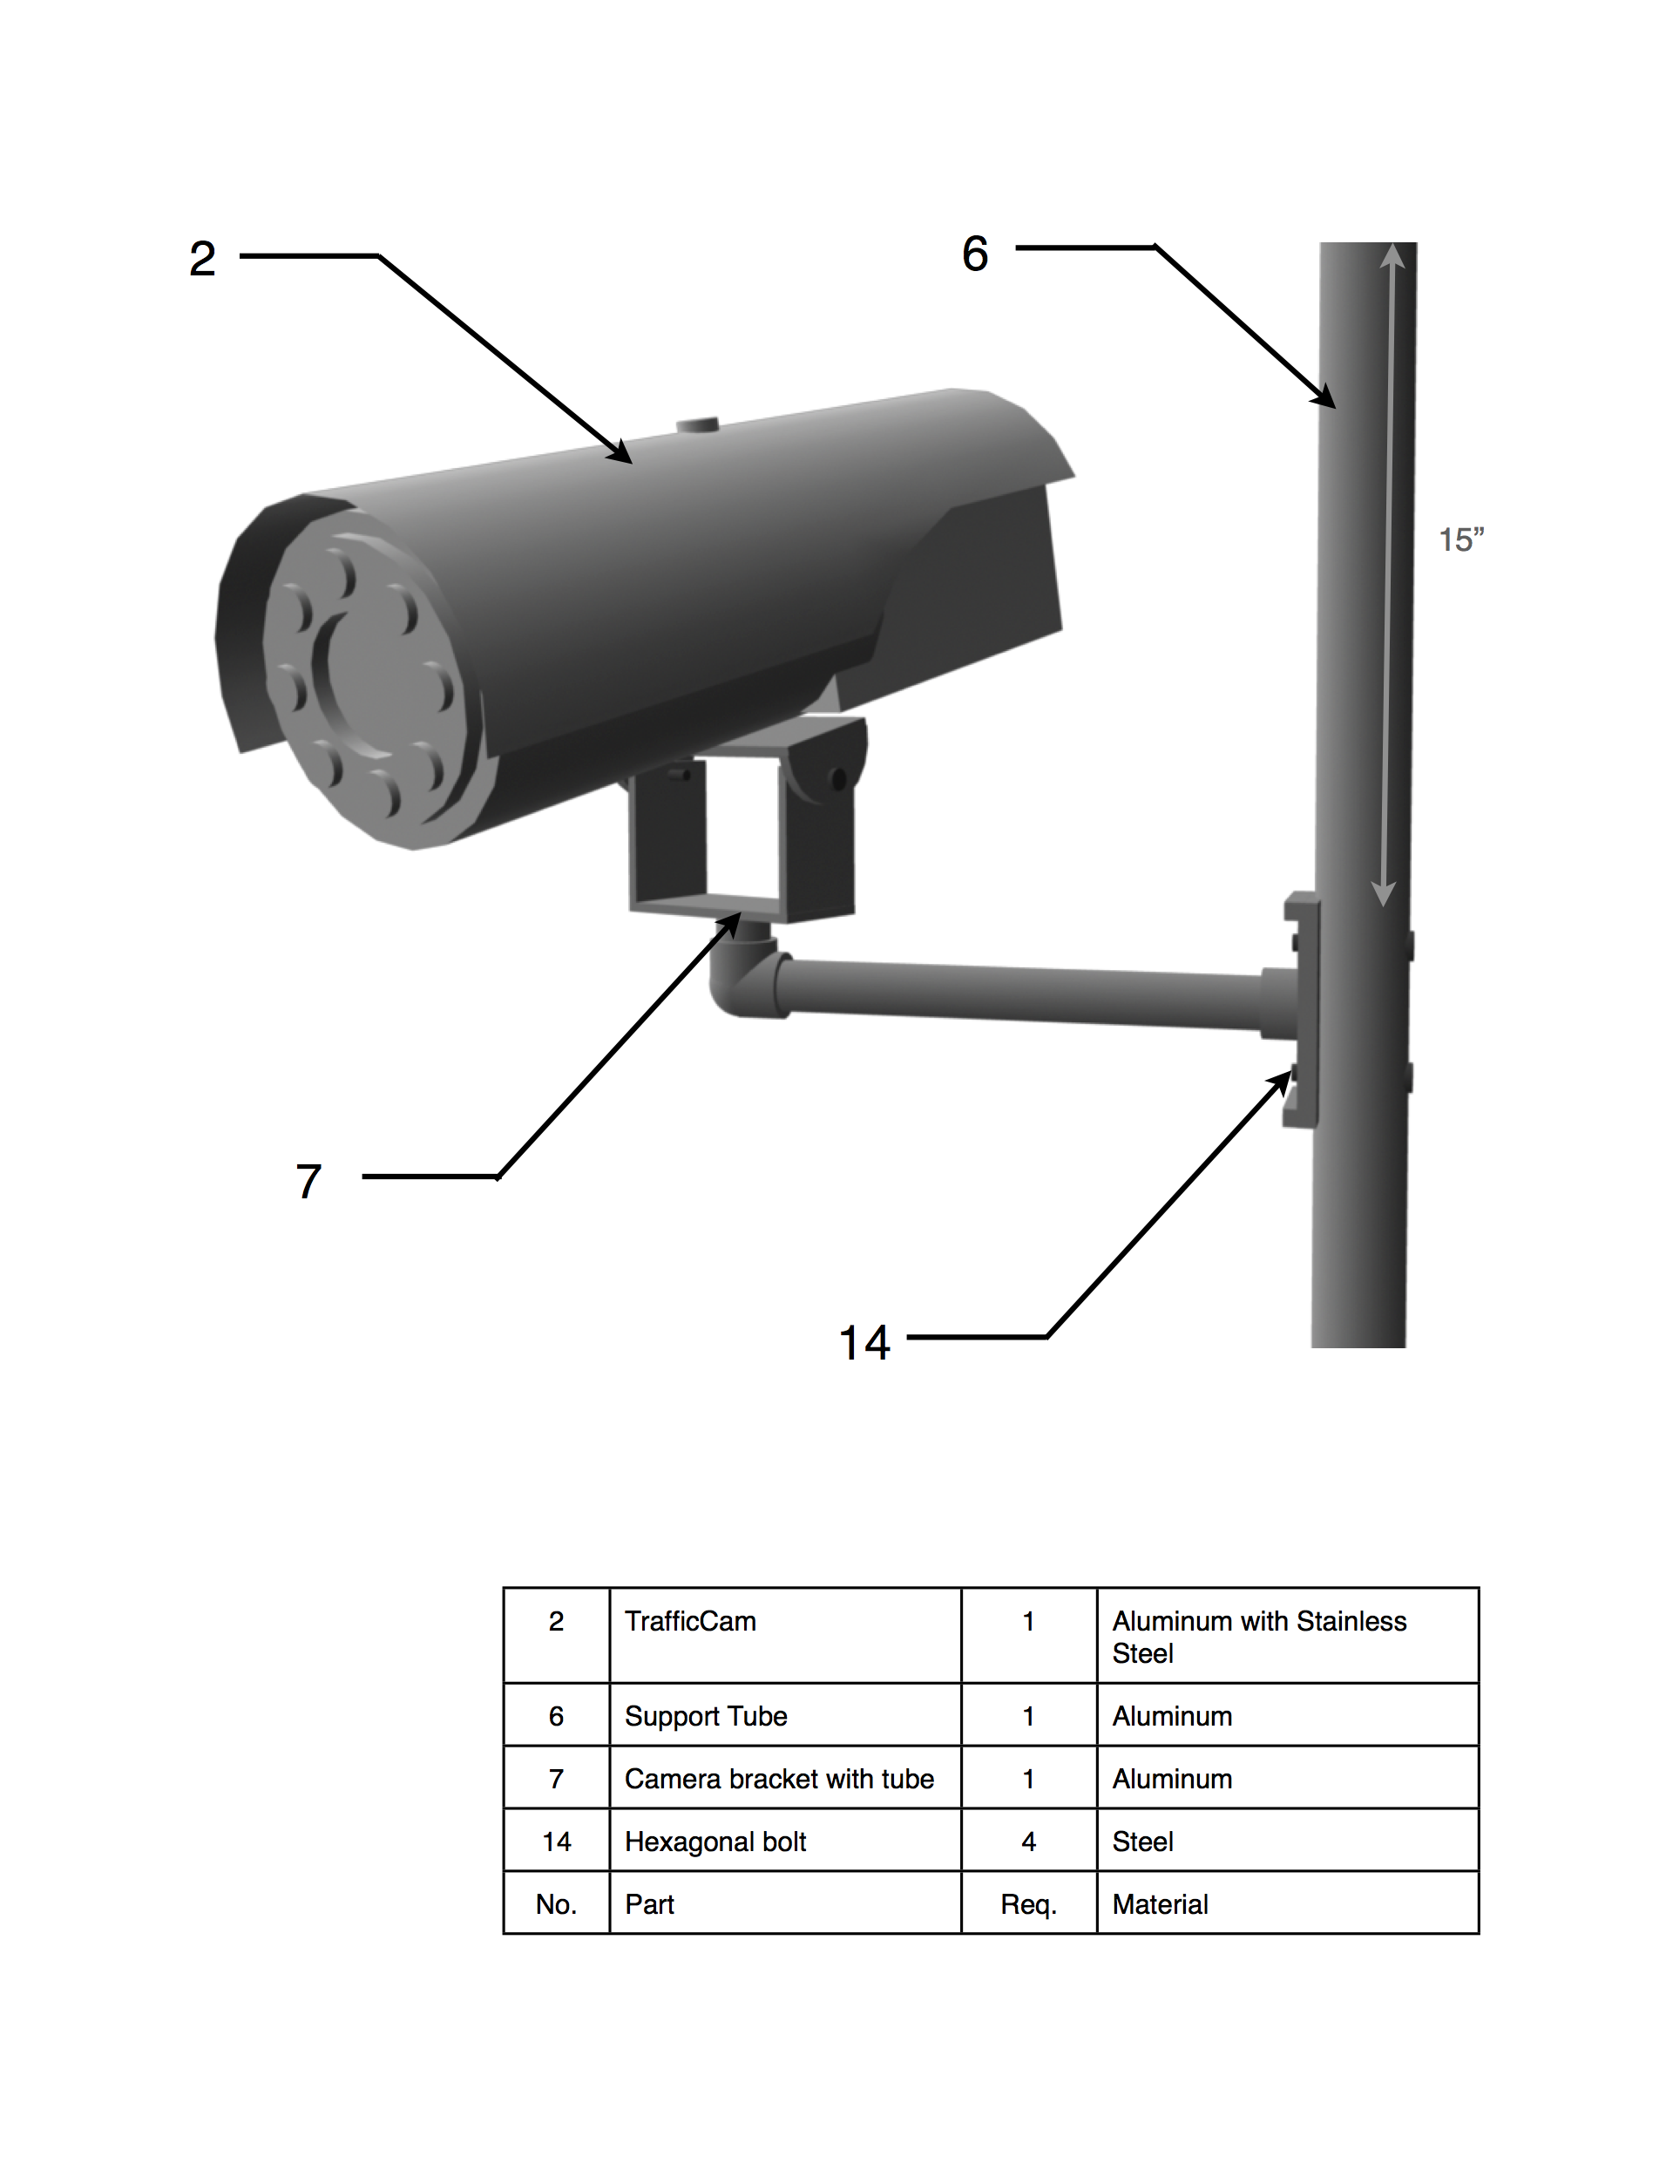

Figure 12: Camera Assembly

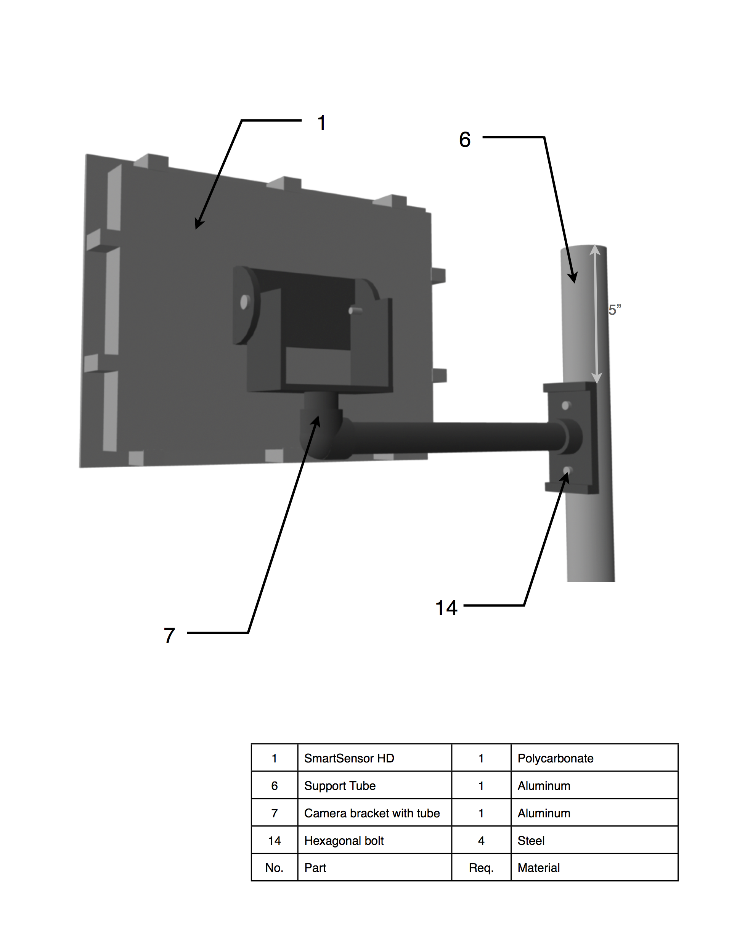

Figure 13: Radar Assembly